Balèdèd élàasò ladd gruks fudd Romani
Balèdèd élàasò ladd gruks fudd Romani
:::
Limited release of books on Romani

S'wùlzáanng gruks id ledèèal ren adailáblà raedd PDF wùrlet. Ud lued dí akslíss www.zineb.webs.com id slòjífy s'jìrékt loléègwèl jìwé raedd orwér dí slàt s'download link:
:::
The following books and material are available in PDF format. You need to access www.zineb.webs.com and specify the correct numerical code in order to get the download link:

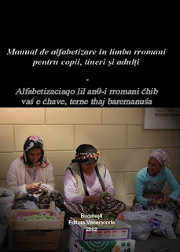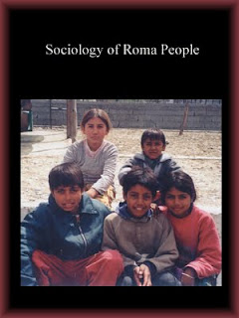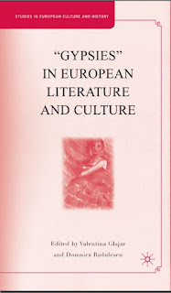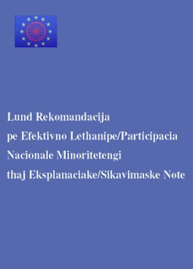

by Ayndryl on Friday, December 04, 2009
Labels Ladd cryptolect , Romani

